Postman Test for APIs:

POST http://localhost:8081/flights

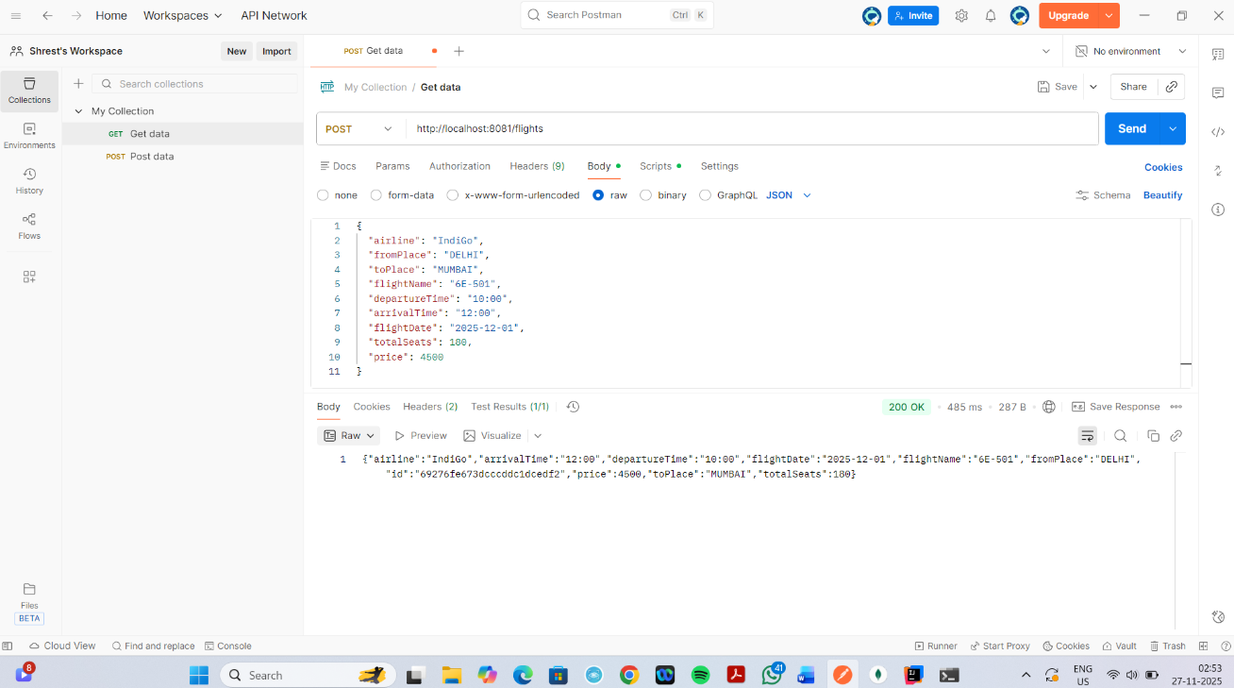

GET http://localhost:8081/flights

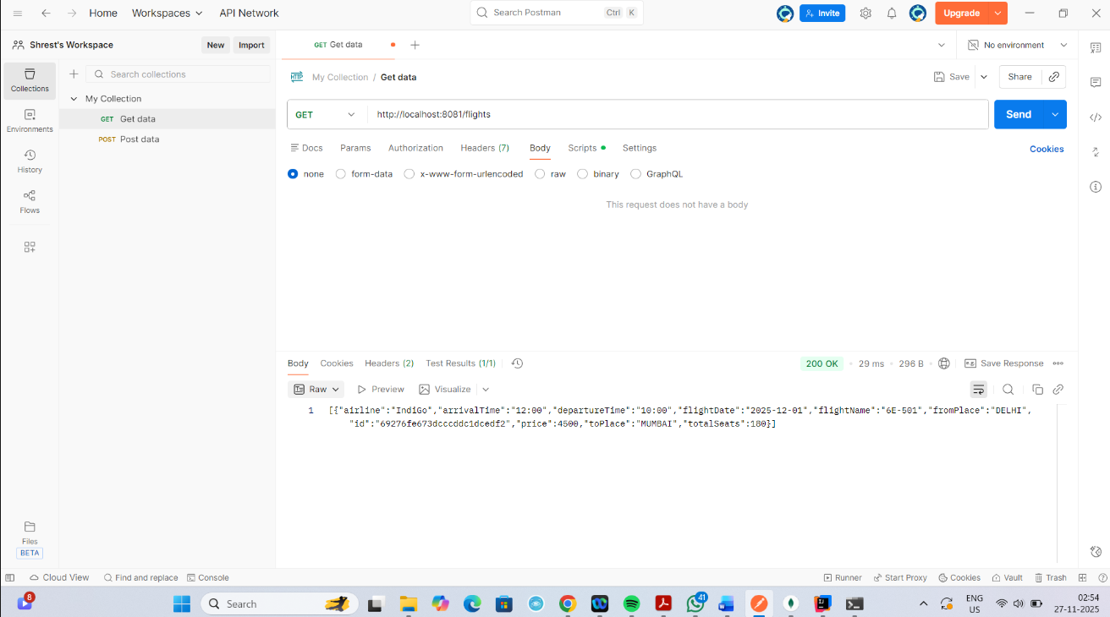

http://localhost:8081/flights/search?from=DELHI&to=MUMBAI

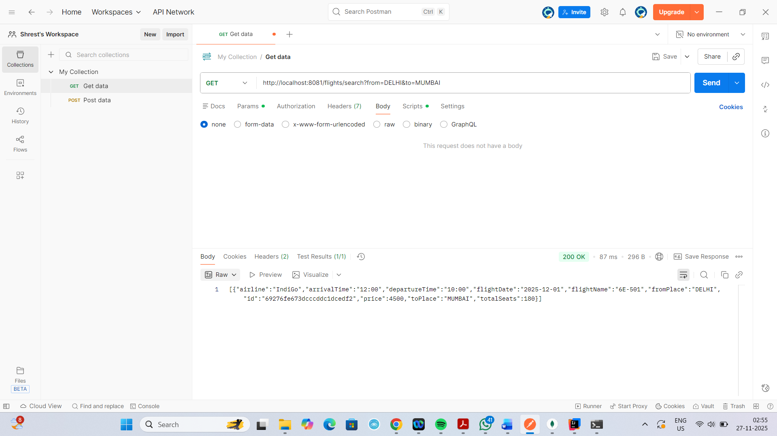

POST http://localhost:8081/booking

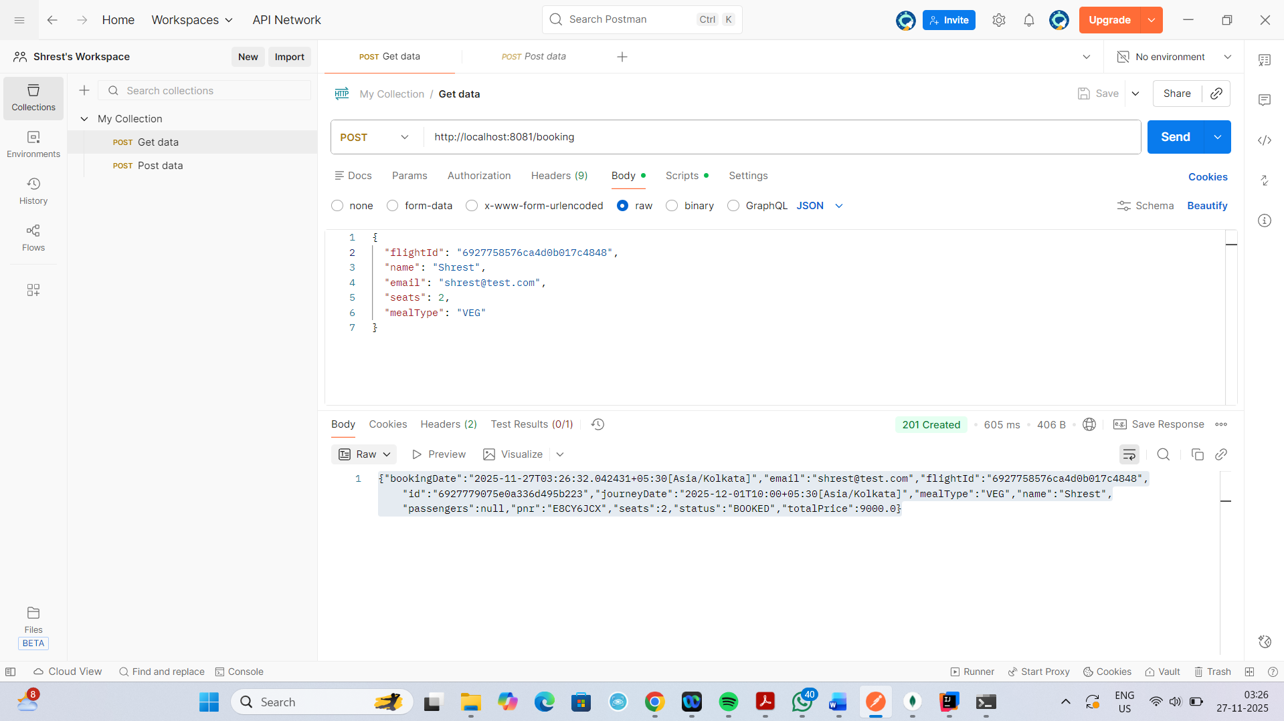

GET http://localhost:8081/booking/ticket/E8CY6JCX
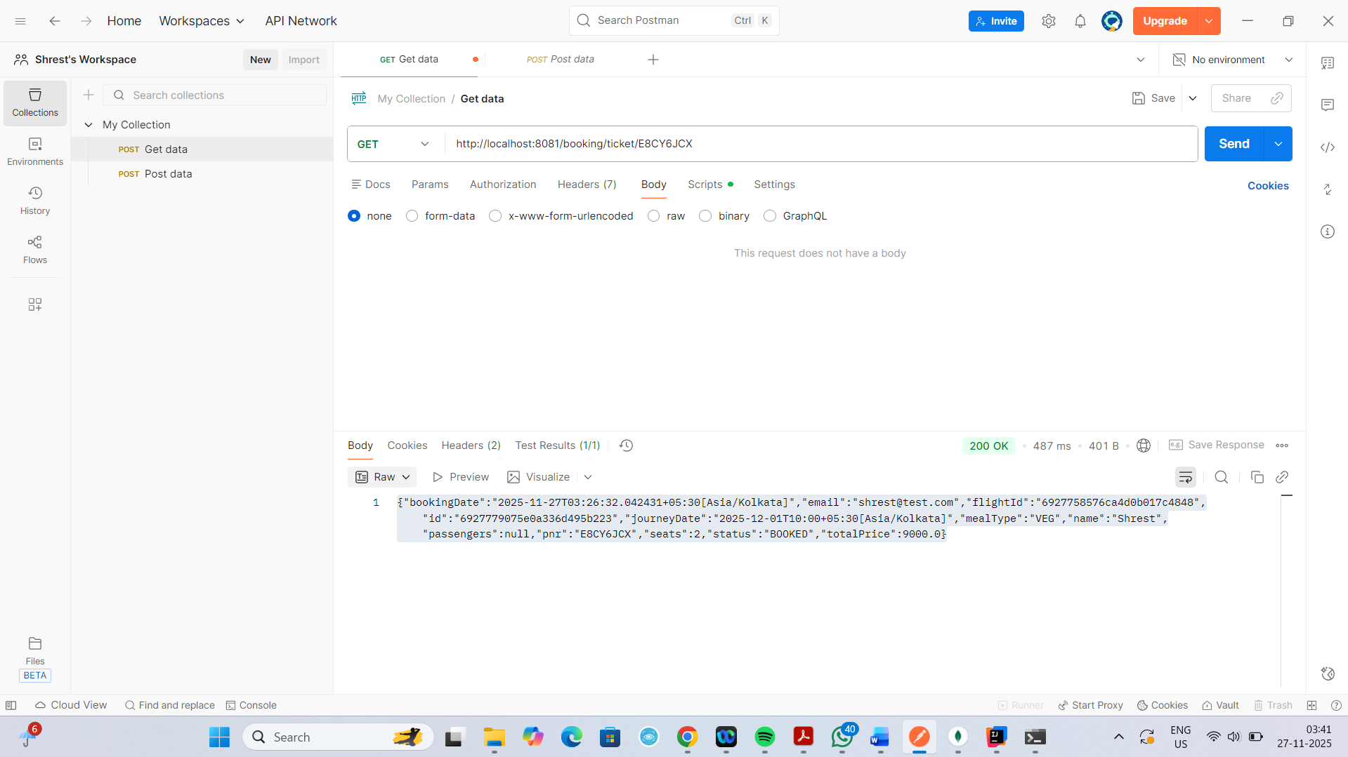

http://localhost:8081/booking/history/shrest@test.com

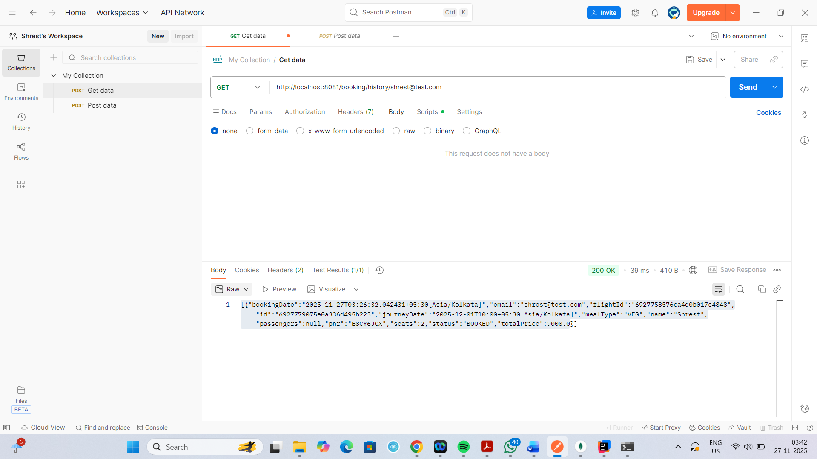

DELETE http://localhost:8081/booking/cancel/E8CY6JCX

